**CMS**

**Medicaid Provider Screening & Enrollment Portal**

**WebSphere Deployment Instructions** **Guide**

**Revision History**

|  |  |  |
| --- | --- | --- |
| **Author** | **Revision Number** | **Date** |
| Venkat Guruvelli | 1.0 | 06/21/2013 |
| 1. LaMora, TopCoder | 1.1 | 08/26/2013 |
|  |  |  |

|  |  |
| --- | --- |
| Revision Number | Sections Changed & Description |
| 1.1 | 1: major enhancements to Deployment instructions.  3.4: Added detail for file identification and settings.  - added detail for DAO/LDAP authentication  3.9: Swapped Step 4 and 5, added detail for step 3  9: Added Section for Minnesota Specific Configuration Changes |

**Table of Contents**

1. Deployment Process 4

2. Organization of Submission 5

3. Application Setup 5

3.1 Software Stack 5

3.2 Database Setup 7

3.3 MMIS Provider data load program setup 8

3.3.1 Build_global.properties File 8

3.3.2 Data load program build scripts setup 8

3.3.3 Data load pointing to local oracle database setup 8

3.3.4 Data load deployment instructions 9

3.4 LDAP settings 9

3.5 WebSphere Deployment Instructions 9

*3.5.1* *Installing the cms portal applicationZoneEar-{version}-SNAPSHOT.ear* 11

4. MQ Setup connection 12

4.1 Websphere environment Setup 35

4.2 Data Source Setup 35

4.3 Install Guvnor 40

4.4 Build Scripts Setup 44

4.5 Configuration Files 44

5. Summary of Deployment steps 45

6. Start Websphere Server 45

7. Portal Application Verification 45

8. Resource Contact List 50

9. Minnesota Specific Configuration Changes 51

# 

# Deployment Process

The application can be deployable in Web Sphere Application Server 8.5. The frontend tier will incorporate HTMLs with JSP. The controllers and JSPs will be packaged into a WAR file, and together with the services, packaged into an EAR file and deployed in a WAS 8.5. The application consists of some EJB based web services to be deployed in WAS 8.5. This application will be packaged as a single jar file. The services will be deployed on a Web Sphere Application Server, and use JPA backed by Hibernate to access the database. Spring is used to give necessary configuration.

Deploying the Application and Applying Updates

At the time of this writing, this application is both installed and updated by downloading the entire code base from github, which can be accessed at this URL:

<https://github.com/nasa/coeci-cms-mpsp>

Github is always updated with the latest code. Github uses a “labeling” system to assign severity, logic type, and other information to individual issues. Labels can be used to group issues by clicking on the label. “Milestones” on github, while also labels, allow the development team to group tickets under that milestone.

Changes and revisions to the Portal are tracked with Issues and Milestones. Milestones tagged with the label “Ready for Deployment” contain repair tickets that are ready for user testing. Milestones that are not tagged with this label, are not ready for testing. Milestones which contain only closed tickets are resolved milestones.

Organizxations interested in using the Portal should always download the current code offered on github.

Tracking Problems with the Portal

Issues and change requests are managed via the github Issues system. Any user may create a Github account, and proceed to log issues. The author of a ticket is expected to assign a severity and note any preference for priority relative to other open tickets. The author should indicate if the ticket is:

**Blocker**: the user cannot procede past this point in the workflow due to this bug.

**Critical:** the issue is very important and must be addressed, though it is not a blocking issue.

**Major:** the issue is important and should be addressed, but is not critical or blocking.

**Minor:** a minor bug or annoyance.

The development team will review tickets, and ask any questions, if necessary. Questions are posted to the ticket, and the author of the ticket (issue) is notified via email. The development team will adjust labels and assign a ticket to a Milestone. The authors of any ticket included in a Milestone will be notified upon assignment.

When a Milestone is ready for user testing, the development team will update the ticket status by assigning the label “Ready to Test.” This indicates to customers that the updates are ready for testing.

Contributing to the Portal via Github

Anybody may contribute to the portal. NASA is the steward of github for the Portal. To request NASA to add your github account to the portal project, please send email to [karl.g.becker@nasa.gov](mailto:karl.g.becker@nasa.gov)

# Organization of Submission

* cms-business-model – contains model files
* cms-business-process – contains the process logic
* cms-portal-services – the enterprise application, including dependencies
* cms-web – the front end code
* db – database setup related files
* docs – contains the deployment guide (this document) and other relevant files for deployment
* services – utility jar shared by web and ejbs

# Application Setup

## Software Stack

* + 1. Oracle 11g
* Please download from [Oracle](http://www.oracle.com/technetwork/database/enterprise-edition/downloads/index.html) and install per product documentation.
  + 1. How to get MPSE Source code
* Getting source code from github <https://github.com/nasa/coeci-cms-mpsp.git>

Please logon to github using this url https://github.com/nasa‎ then find project [coeci-cms-mpsp](https://github.com/nasa/coeci-cms-mpsp) and please see attached screen shots

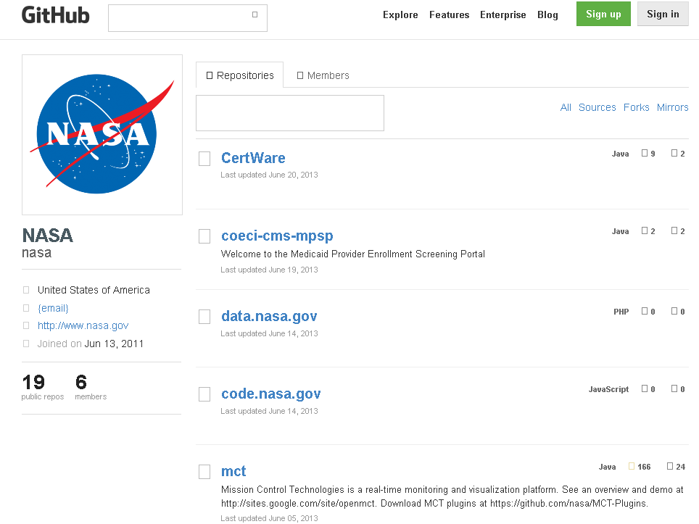

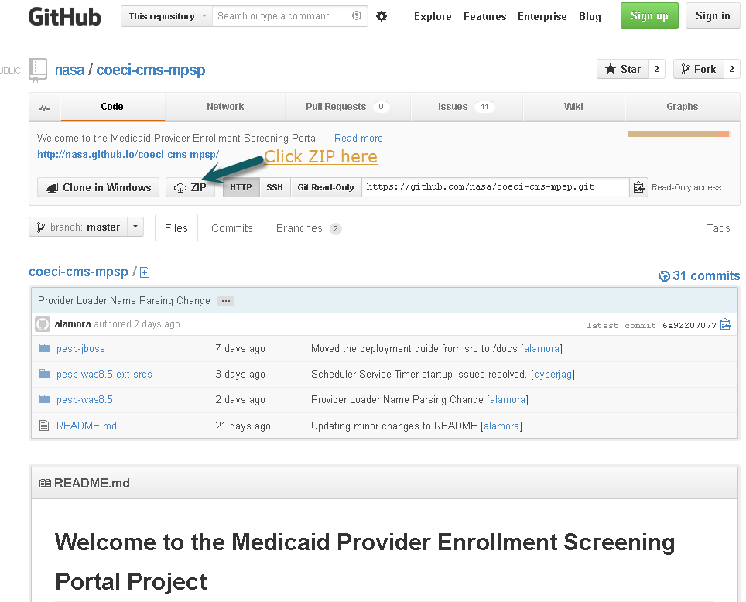

* + 1. Guvnor 5.3
* Download the software from <http://download.jboss.org/drools/release/5.3.0.Final/>
  + 1. Websphere 8.5
* Download the software from [IBM](http://www-01.ibm.com/software/webservers/appserv/was/) and install per product documentation. This guide refers to the application server installation folder as <appserver.dir>

## Database Setup

Download the database dump file from this thread:

<http://apps.topcoder.com/forums/?module=Thread&threadID=786941&start=0>

And import it to your installation (via TOAD, command line or other tools like SQLDEVELOPER).

## MMIS Provider data load program setup

#### CMS Portal Code must be available

* ***Legacy Mapping Table must be up to date***

## Build_global.properties File

This file must be modified to reflect the user environment.

|  |  |  |
| --- | --- | --- |
| **Property Name** | **Description** | **Example Setting** |
| portal_code_base | Location of the portal application code | Z:/cms-was |
| was.home | Installation directory of WAS | C:/opt/IBM/WebSphere/AppServer |
| file_1 | Location of provider file | data/WRKHASH1.txt |
| file_2 | Location of owner file | data/WRKHASH2.txt |
|  |  |  |
|  |  |  |
|  |  |  |

## Data load program build scripts setup

ant import-mappings will run the mapping import using the data files configured in build.properties

Mapping import is a replace-all procedure, it will remove any mapping already in the database.

ant run-data-load will run the data import using the data files configured in build.properties

Data load will replace any profile with the same legacy id, it will however keep any tickets/audits associated with those profiles.

## Data load pointing to local oracle database setup

You must replace the connection settings in this file:

*/mmis_load_utility/src/META-INF/persistence.xml*

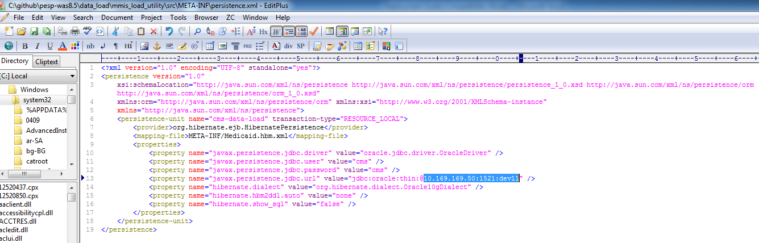

## Data load deployment instructions

1. Backup the database
2. Modify build.properties
3. Modify persistence.xml
4. execute ant run-data-load

Rejected and processed record logs will be generated on the work folder, the file pattern is

accepted_1_<process id>.txt – contains the successful imports from file 1

rejected_1_<process id>.txt – contains the failed imports from file 1

accepted_2_<process id>.txt – contains the successful imports from file 2

rejected_2_<process id>.txt – contains the failed imports from file 2

## LDAP settings

These settings are found in the file cms.properties.

#LDAP settings

ldap.java.naming.factory.initial=com.sun.jndi.ldap.LdapCtxFactory

ldap.java.naming.provider.url=<LDAP SERVER URL>

ldap.java.naming.security.authentication=simple

ldap.java.naming.security.principal=<LDAP ADMIN>

ldap.java.naming.security.credentials=<LDAP ADMIN PASSWORD>

# replace with Directory Provider Schema properties (slightly varies per product)

ldap.userDnPattern=<DISTINGUISHED NAME PATTERN FOR USERS>

ldap.groupsSearchBase=<SEARCH BASE FOR GROUPS>

ldap.userSearchBase=<SEARCH BASE FOR USERS>

ldap.userSearchFilter=<SEARCH PATTERN FOR USERS>

ldap.groupSearchFilter=<SEARCH PATTERN FOR GROUP MEMBERS>

extsources.TEST.base=<ENDPOINT BASE URL FOR EXT SOURCES APP>

**Note: Not all configurations require LDAP.** It is possible to use only DAO authentication. By default, the portal first tests the local database to find the credentials of the user by making a call to “DomainDatabaseAuthenticationProvider”. If no user is found, the portal tests an LDAP connection, if one exists, by calling “DomainLdapAuthenticationProvider”. If no credentials are found on either search, the Portal returns an error and logs a configuration error to the application log.

## WebSphere Deployment Instructions

Login to the Websphere IBM admin console using secure URL

e.g. <https://192.168.1.35:9043/ibm/console/logon.jsp>

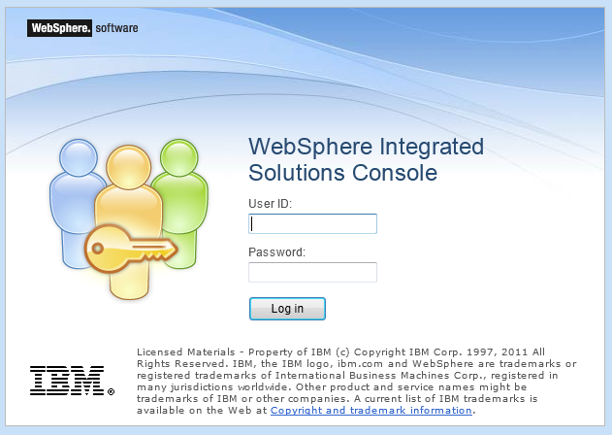

### *Installing the cms portal applicationZoneEar-{version}-SNAPSHOT.ear*

cms-portal-services.ear

1. Logon to the deployment manager and you can see welcome screen**.**

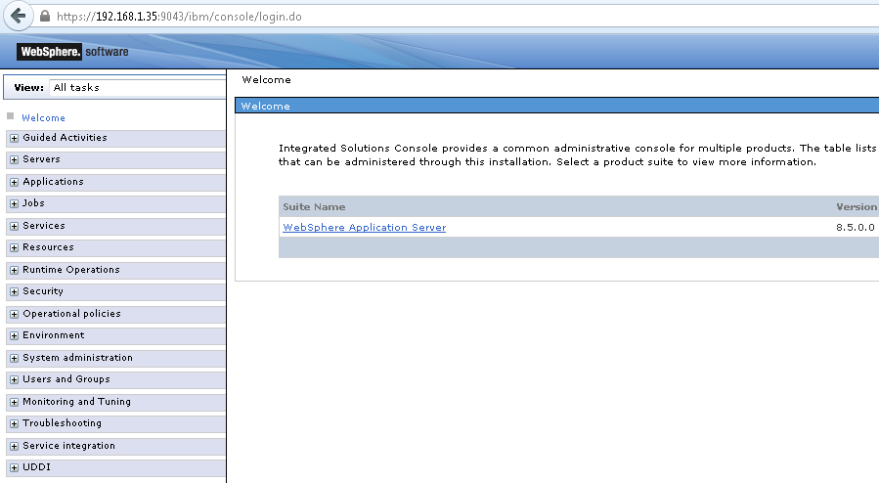

## MQ Setup connection

You need the following information to be setup in your JMS under resources

1. MQ server connection details
2. Queue Manager Name
3. Queue Name where to POST messages
4. Queue Name where to RECEIVE messages

STEP 1 - Setup Connection To MQ

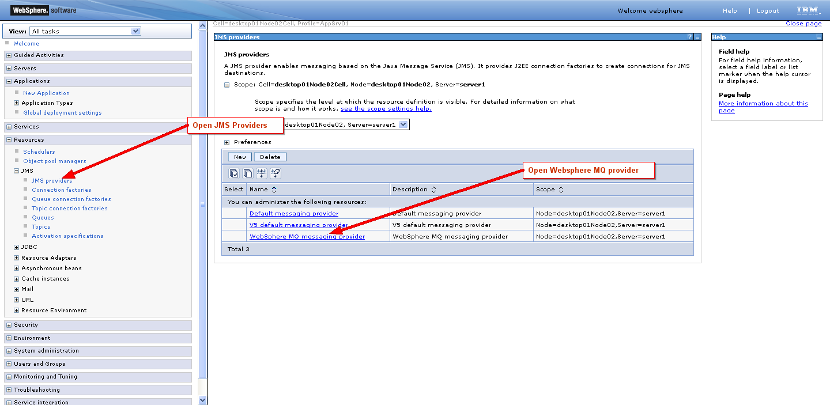

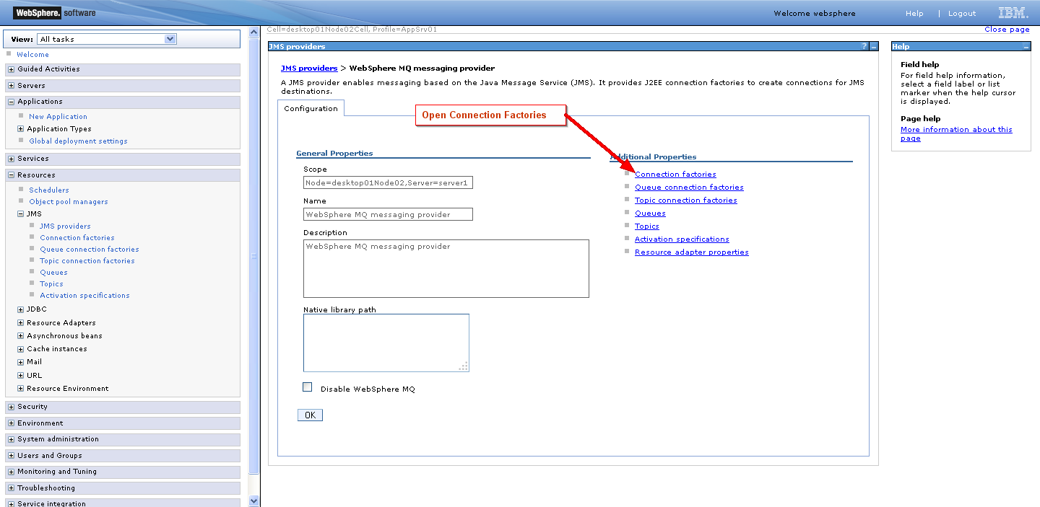

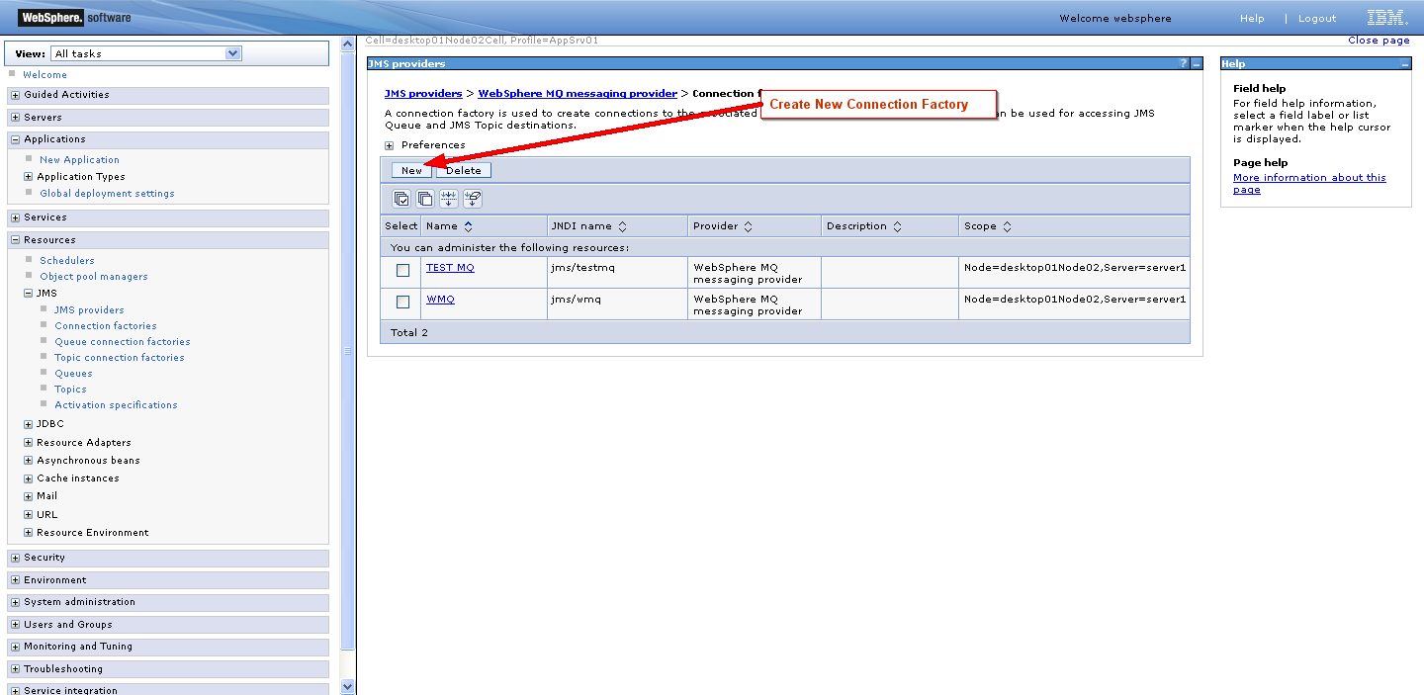

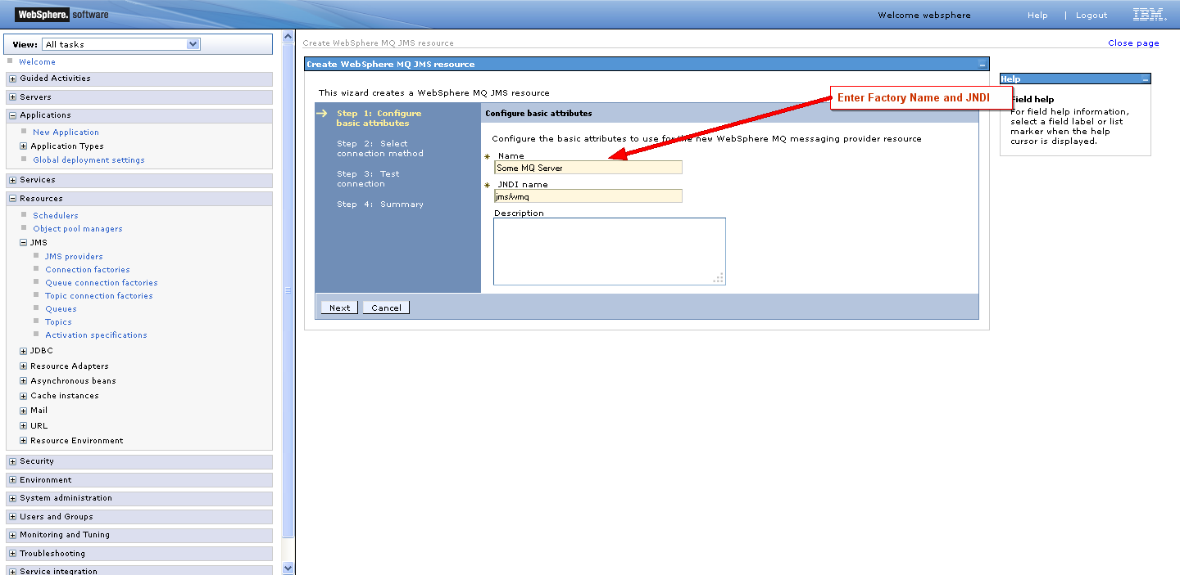

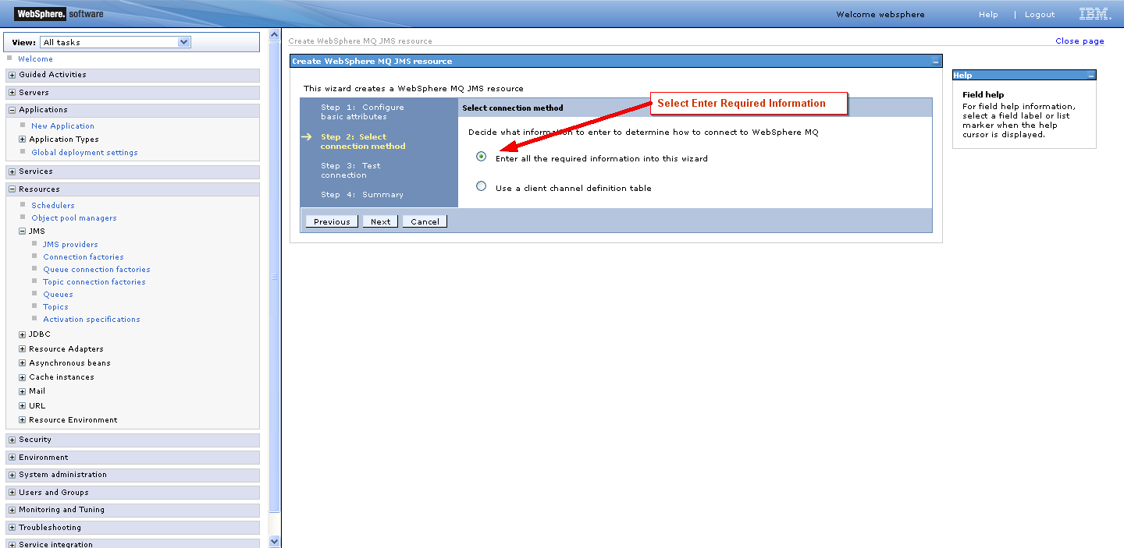

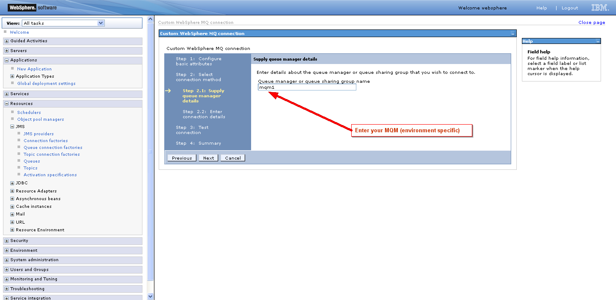

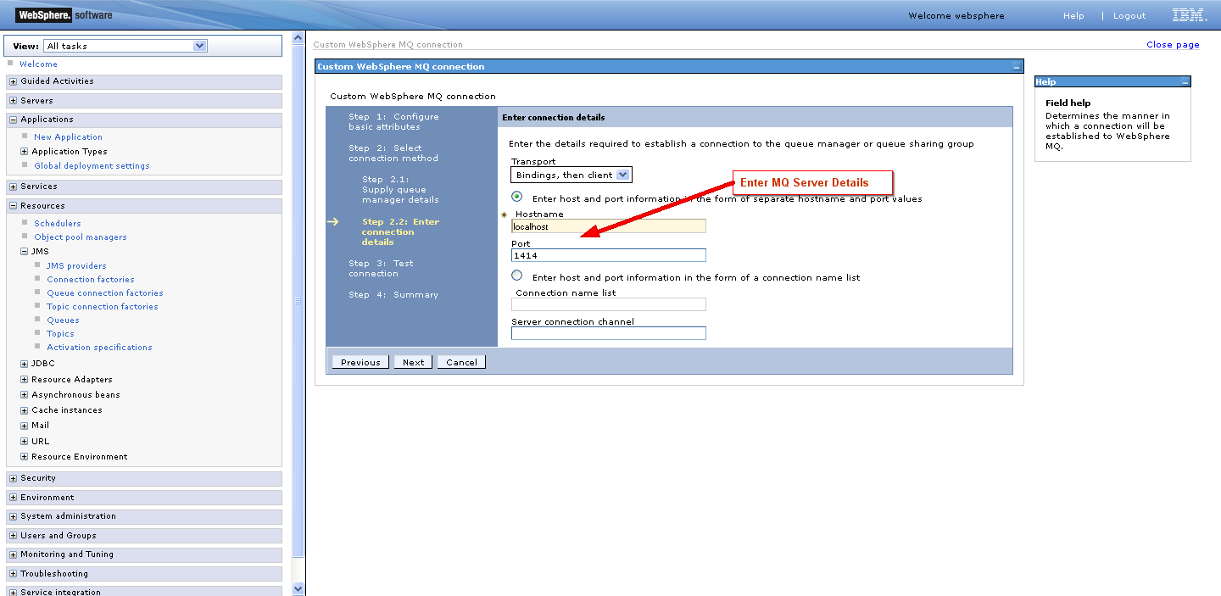

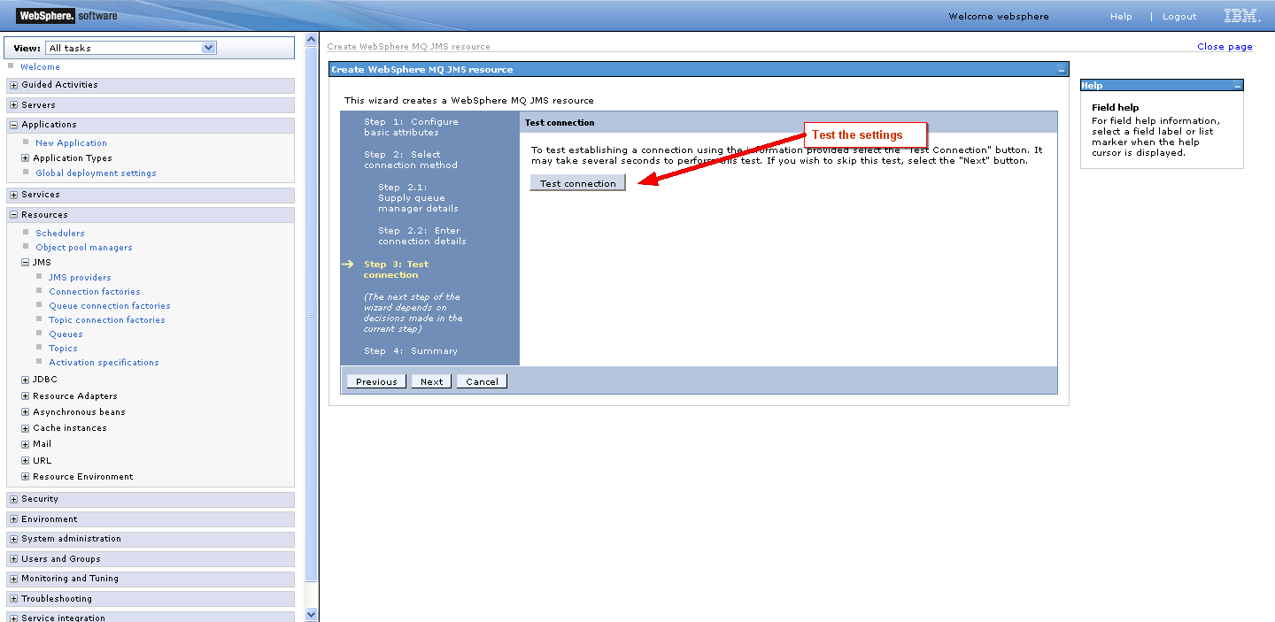

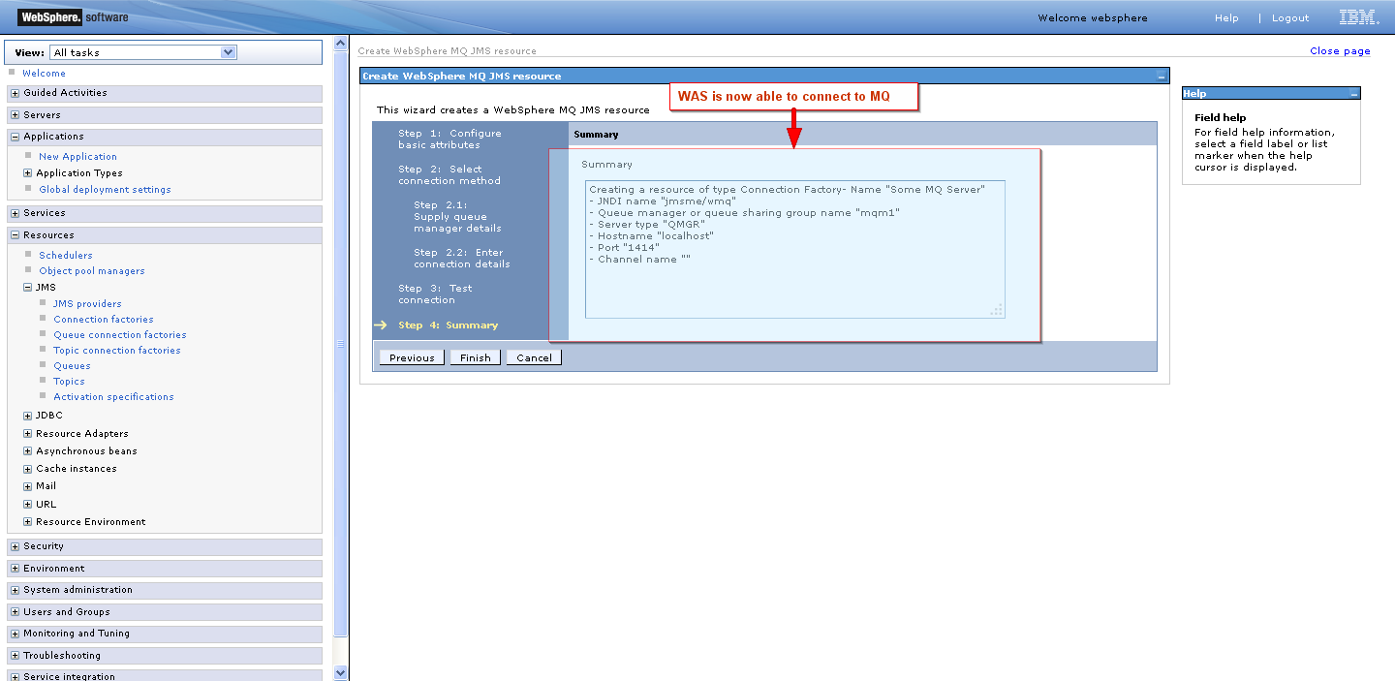

STEP 2 - SETUP A SEND QUEUE AND A RECEIVE QUEUE

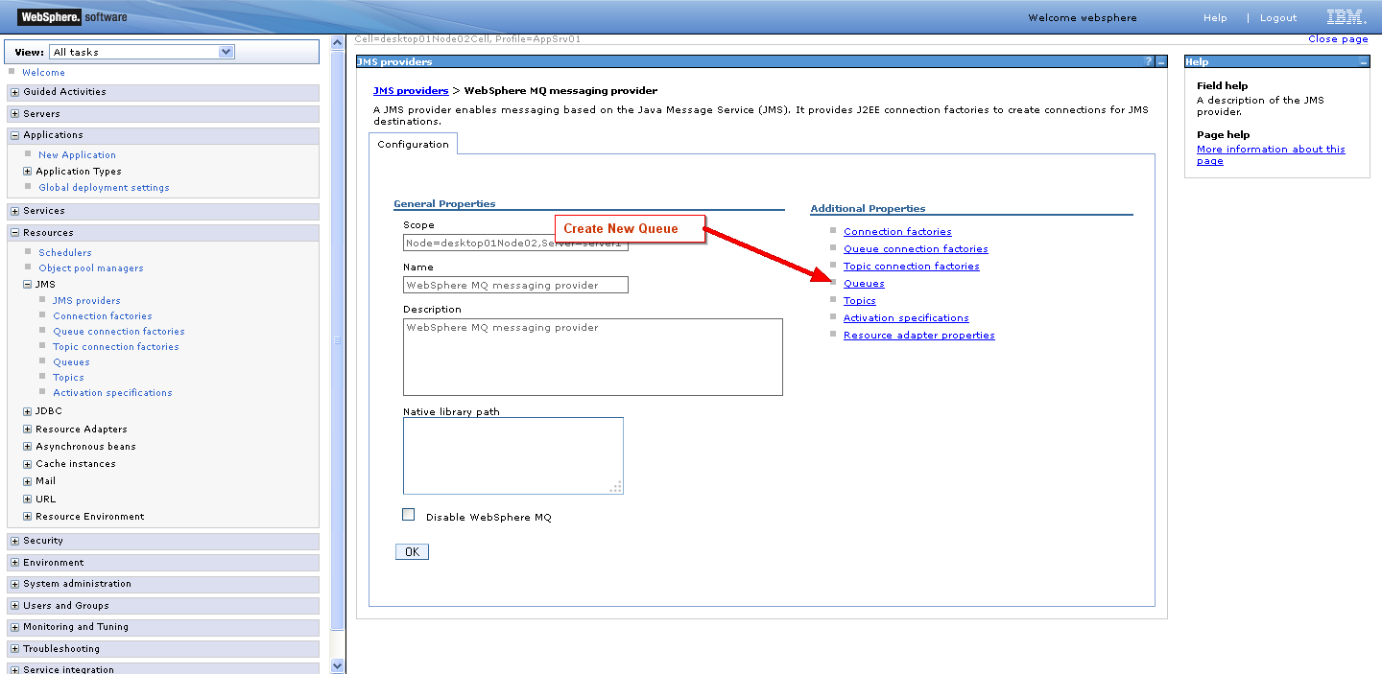

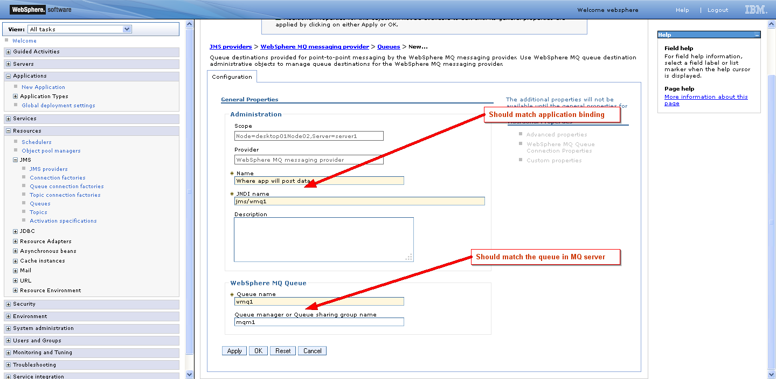

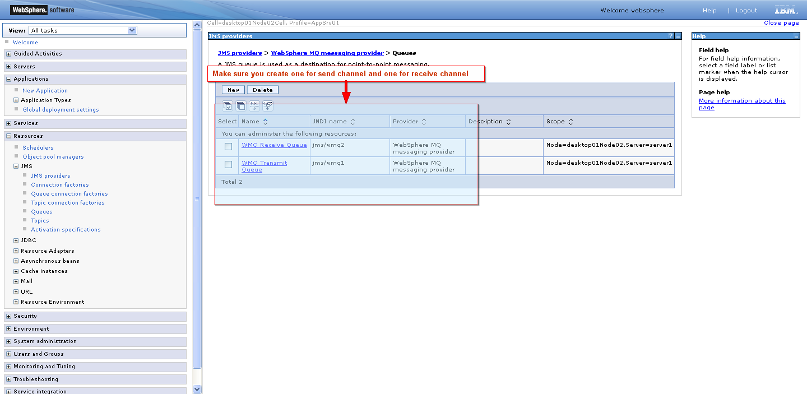

STEP 3 - Create an activation spec for the response (where the bean will listen for responses)

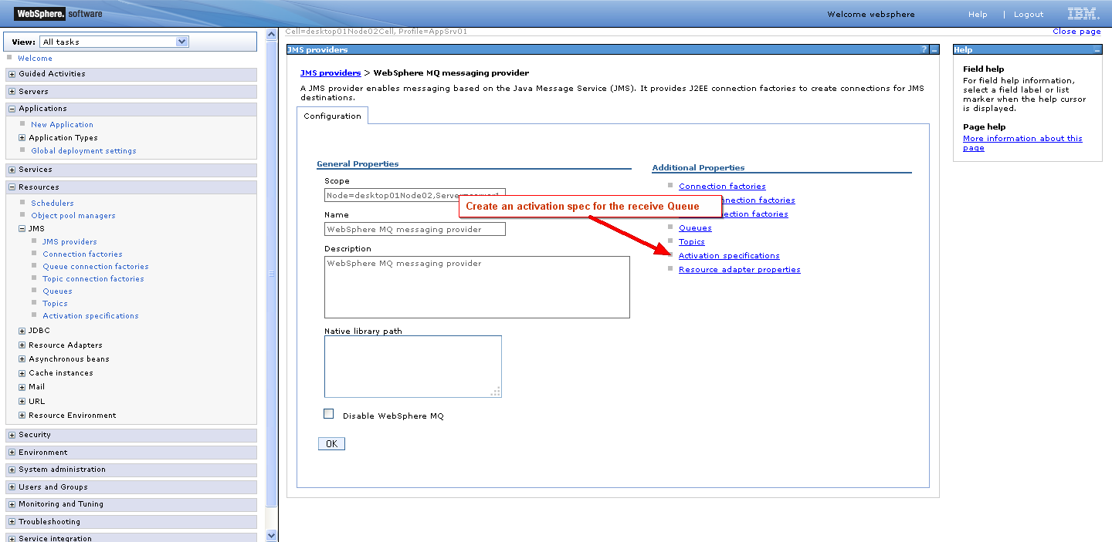

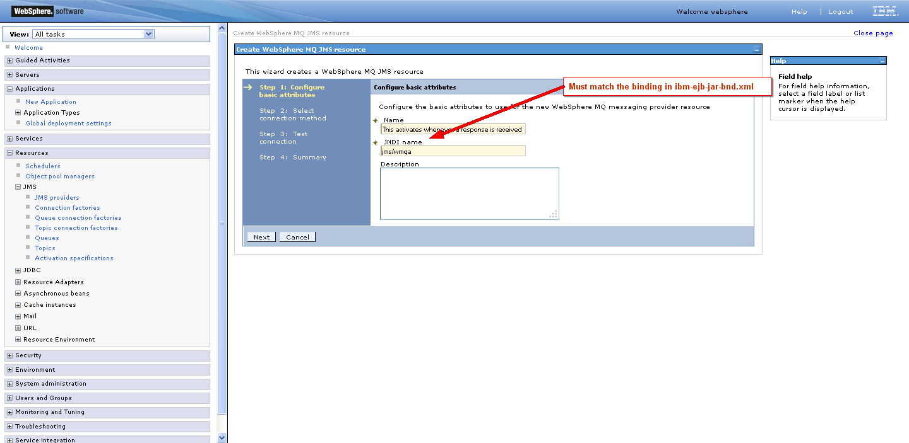

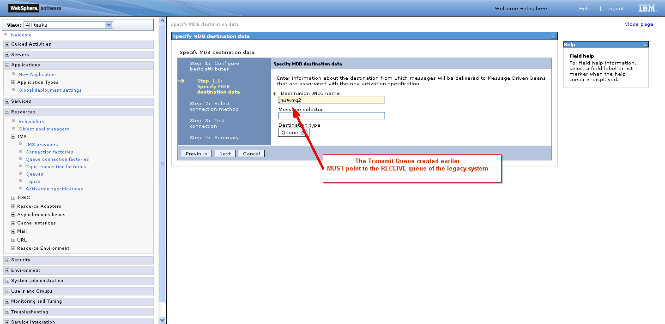

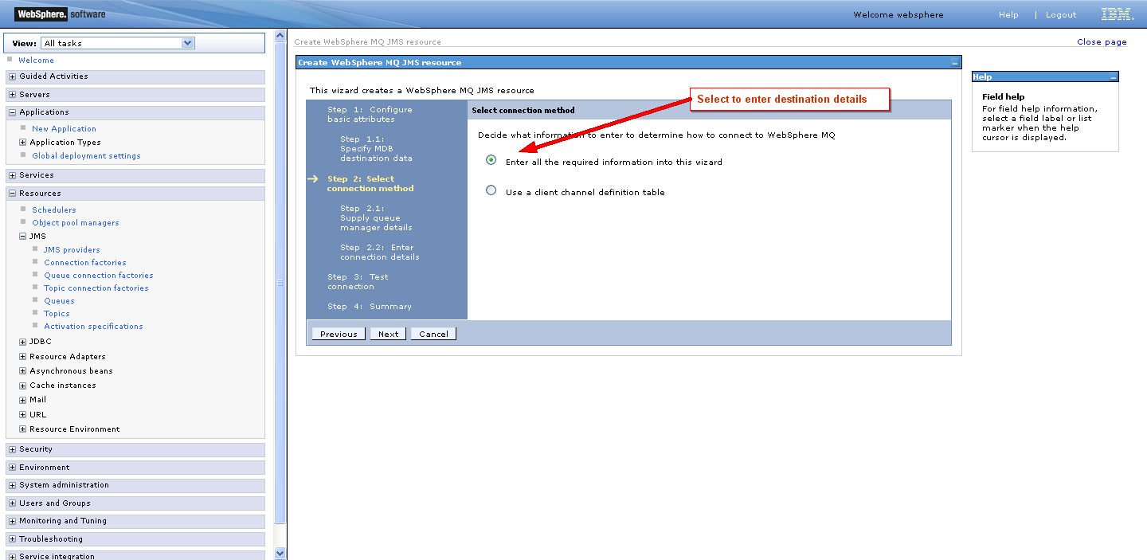

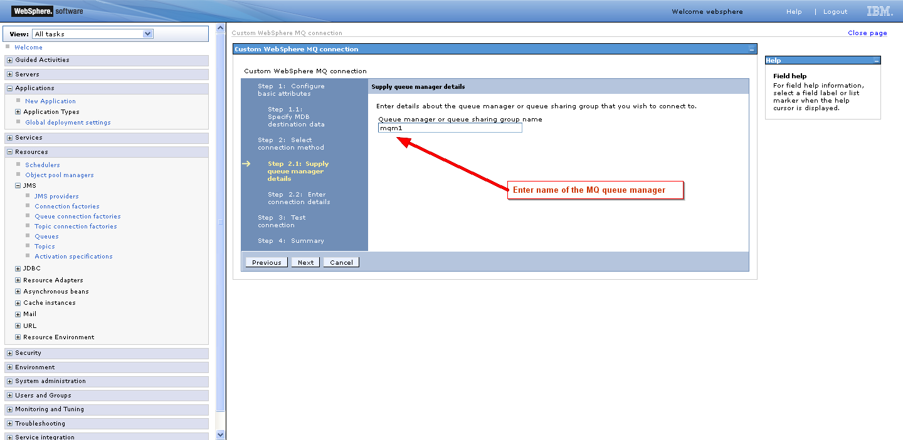

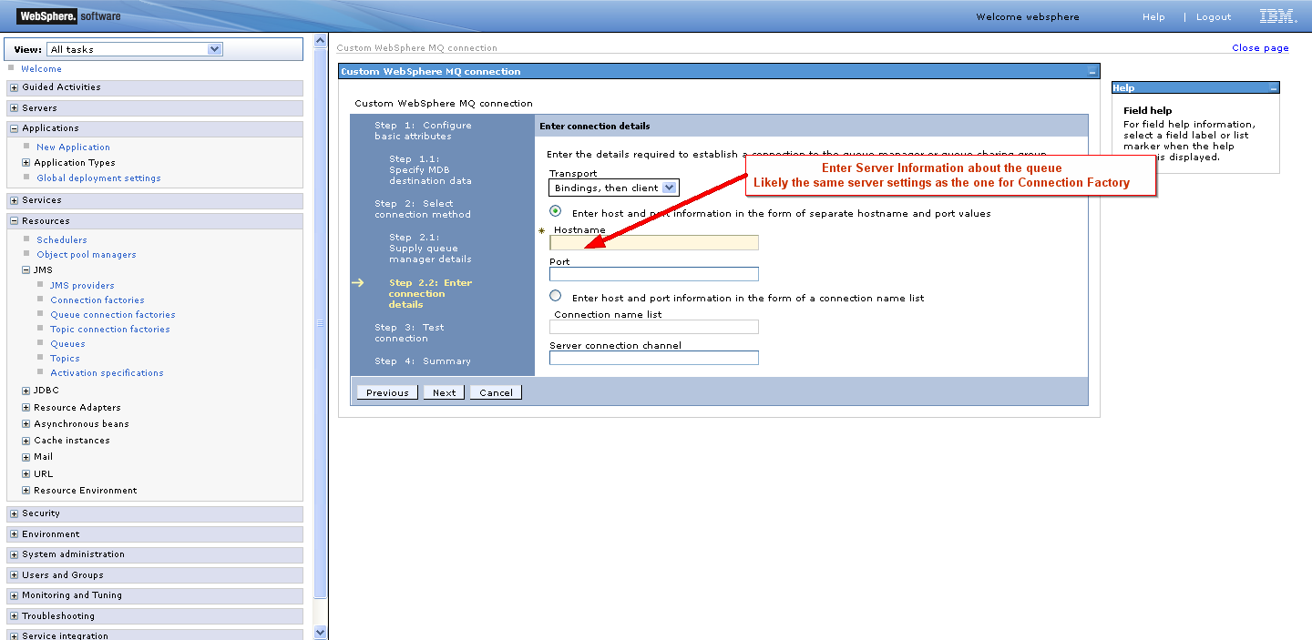

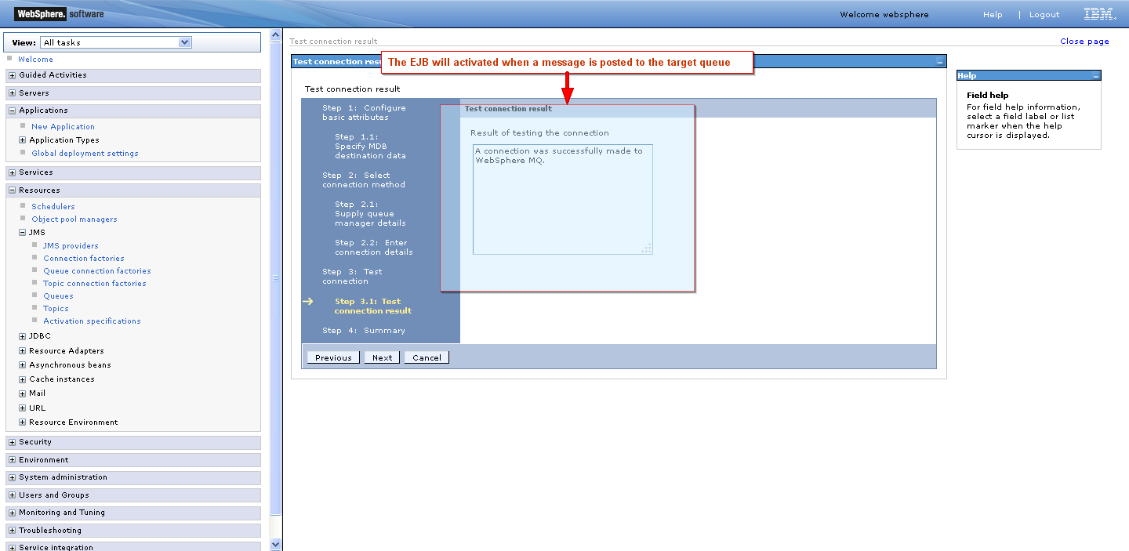

Please take note of whatever JNDI names you enter. They should match the values you put in

/cms-portal/cms-business-process/src/main/resources/META-INF/ibm-ejb-jar-bnd.xml

Specifically:

This is the config for our RECEIVE queue (where MN will post the response) – it should match the JNDI names for the activation spec and the receive queue created, it triggers the bean when a message is posted on the queue mapped to *jms/wmq2* (one of the queues in step 2), connection is established using the settings of *jms/wmqa*(created in step 3)

<message-driven name=*"DataSynchronizationMessageBean"*>

<jca-adapter activation-spec-binding-name=*"jms/wmqa"* destination-binding-name=*"jms/wmq2"* />

</message-driven>

This is the config for or TRANSMIT queue (where MN is waiting for messages). JBPM will send approved requests to the queue mapped to *jms/wmq1* (one of the queues in step 2) the connection is established through the connection factory mapped to *jms/wmq1* (created in step 1)

<session name=*"ProviderEnrollmentServiceBean"* simple-binding-name=*"cms-portal-services/ProviderEnrollmentServiceBean/local"*>

<message-destination-ref

name=*"gov.medicaid.services.impl.ProviderEnrollmentServiceBean/dataSyncQueue"*

binding-name=*"jms/wmq1"* />

<resource-ref

name=*"gov.medicaid.services.impl.ProviderEnrollmentServiceBean/mqConnectionFactory"*

binding-name=*"jms/wmq"* />

</session>

Click Applications 🡺 [New Application](https://192.168.1.35:9043/ibm/console/com.ibm.ws.console.appmanagement.action.forwardCmd.do?csrfid=-310947372&forwardName=newapps.config.view&WSC=true) 🡺 [New Enterprise Application](https://192.168.1.35:9043/ibm/console/com.ibm.ws.console.appmanagement.action.forwardCmd.do?csrfid=-310947372&forwardName=appmanagement.upload&lastPage=newapps.config.view&resourceUri=serverindex.xml&parentRefId=&contextId=cells%3AstallionCell01%3Anodes%3AstallionCellManager01&perspective=tab.configuration)

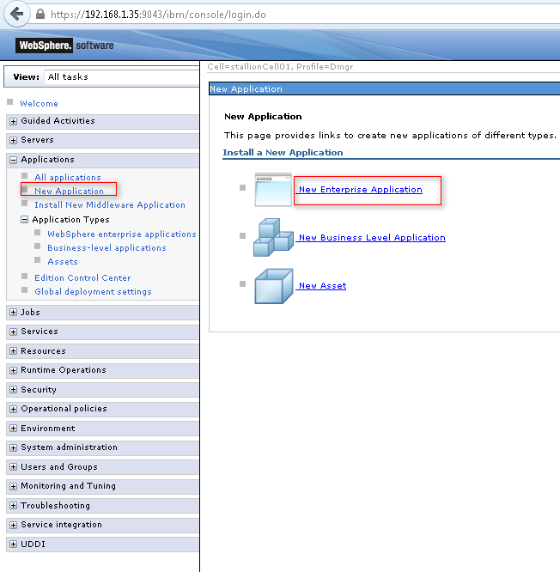

OR Click Applications 🡺 [Application Types](javascript:expandCollapse('7');) 🡺 [WebSphere enterprise applications](https://192.168.1.35:9043/ibm/console/navigatorCmd.do?csrfid=-310947372&forwardName=ApplicationDeployment.content.main&WSC=true)

Click “Install” and upload the generated ear file from by the ant script

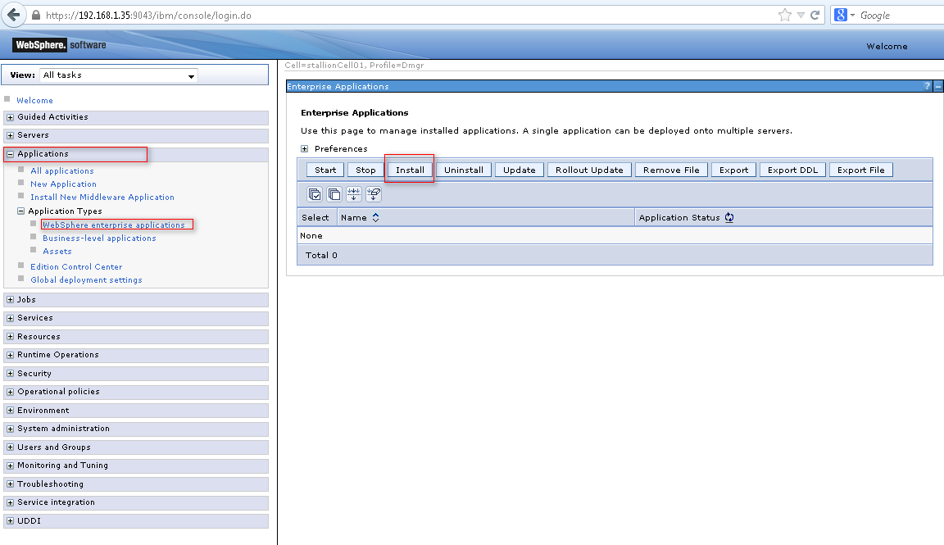

Click on the **Browse** button to locate the cms-portal-services.ear

applicationZone-{version}-SNAPSHOT.ear file. The browser will open the next screen.

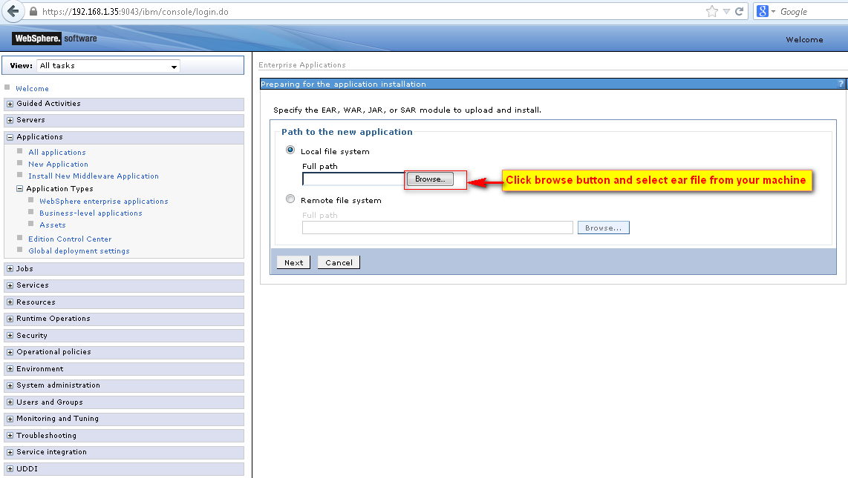

Select EAR file from local build folder

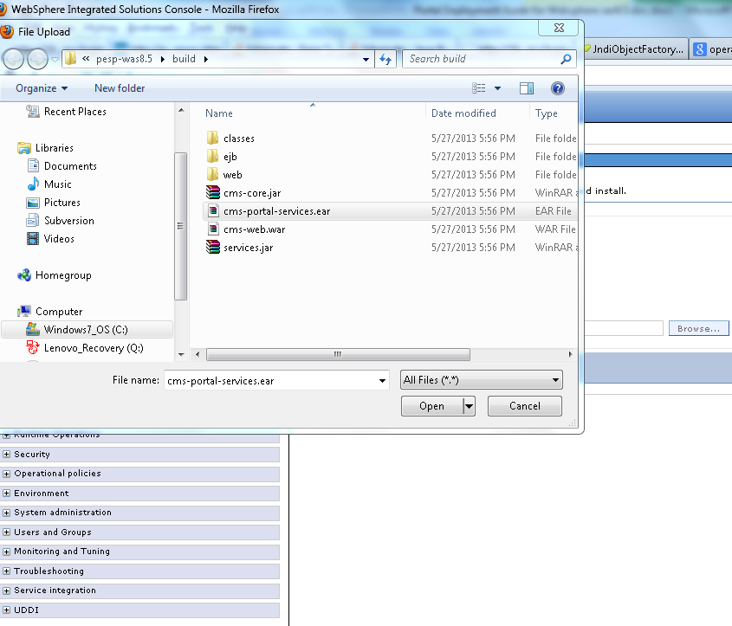

Click **Next** and wait until loads ear file. This may take several minutes to load ear into portal server 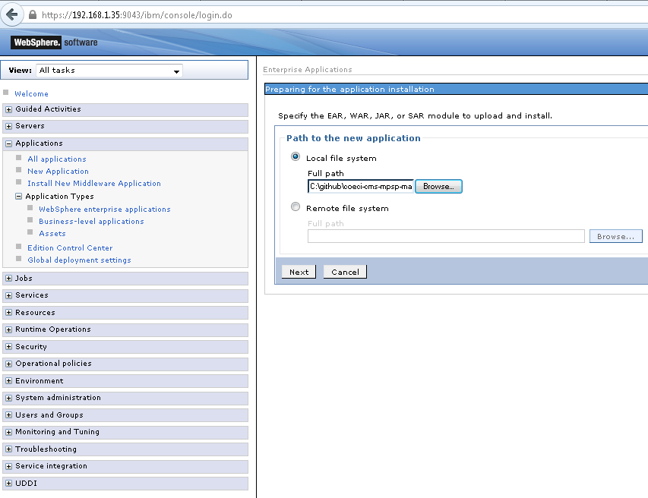

Click **Next**. Accept All Defaults for all the screens

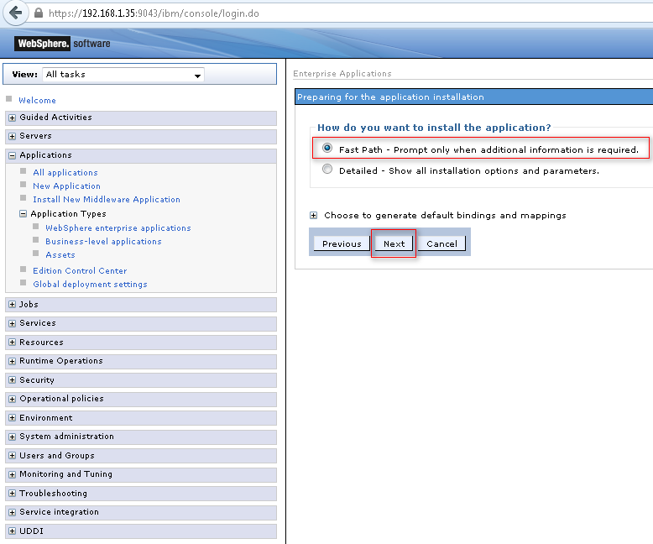

Click **Next**.

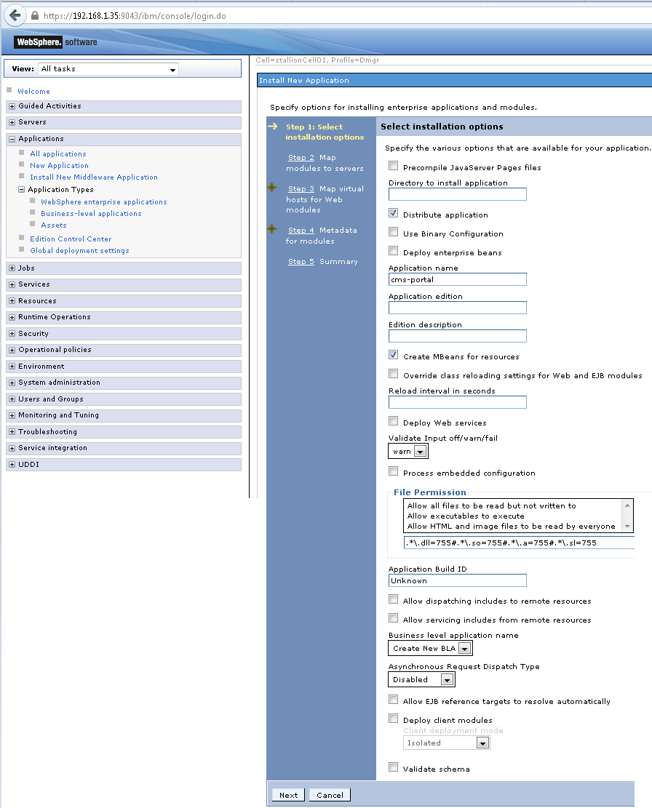

Click **Next** and select Clusters and servers: then click **APPLY**

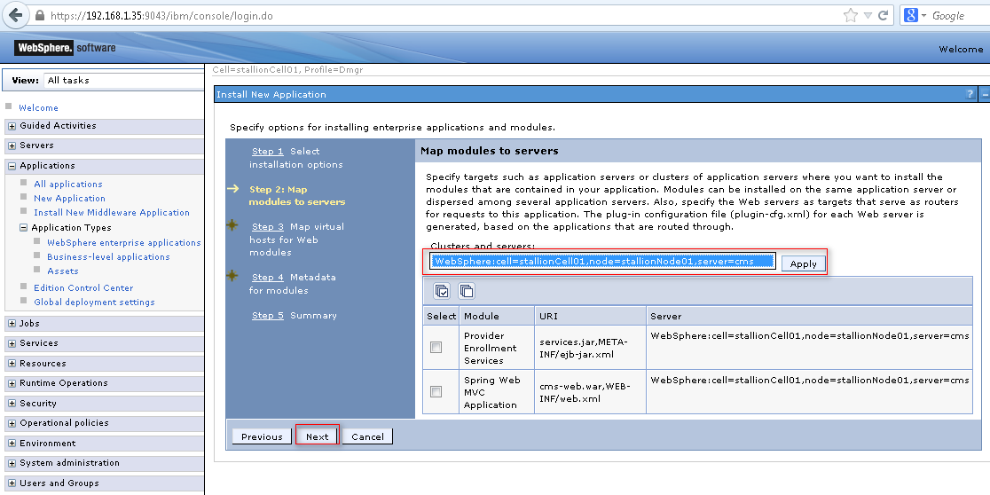

Click **Next**.

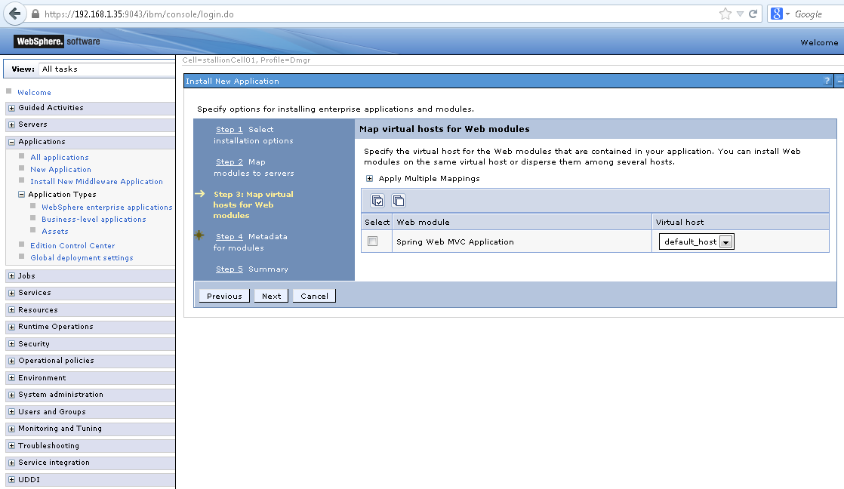

Click **Next**.

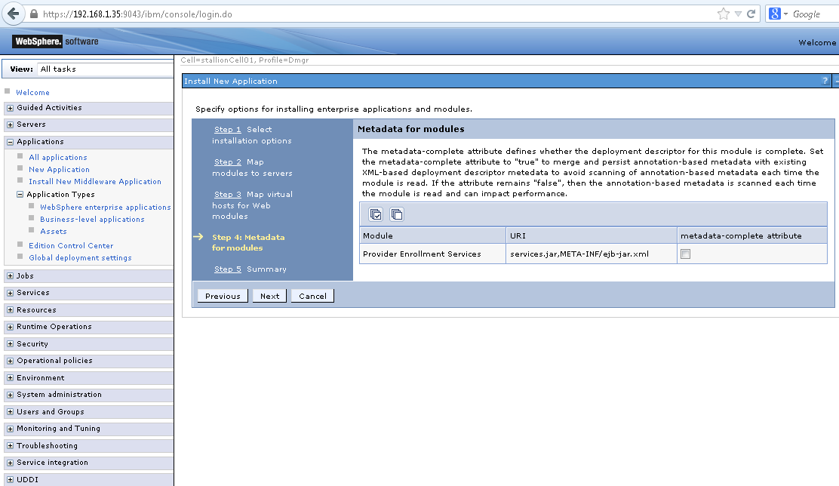

Click **Finish**.

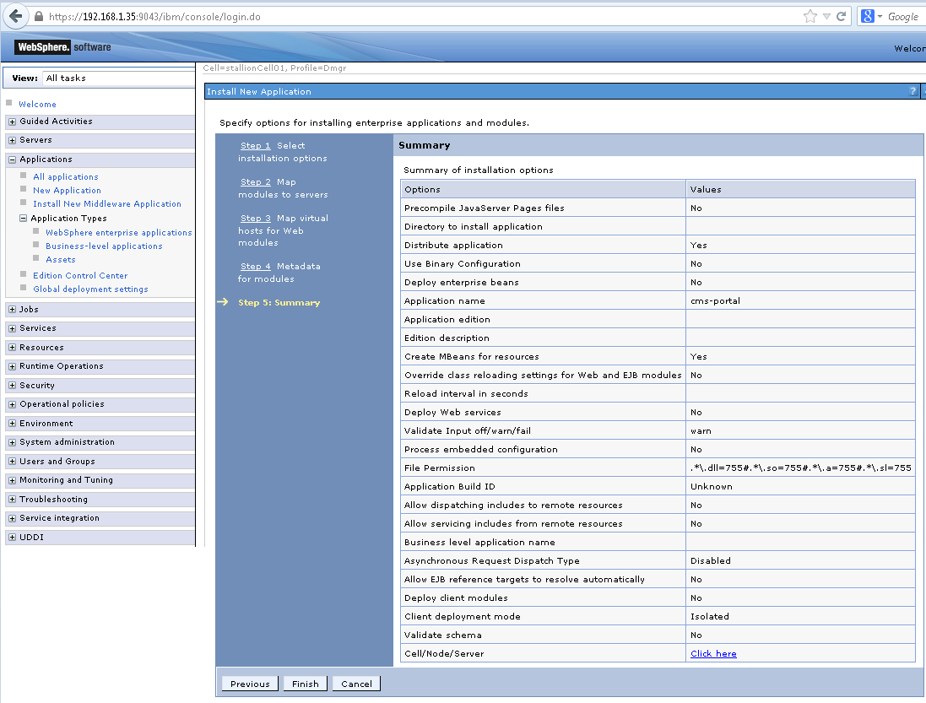

Wait for installation to complete, then click Review and Click Save.

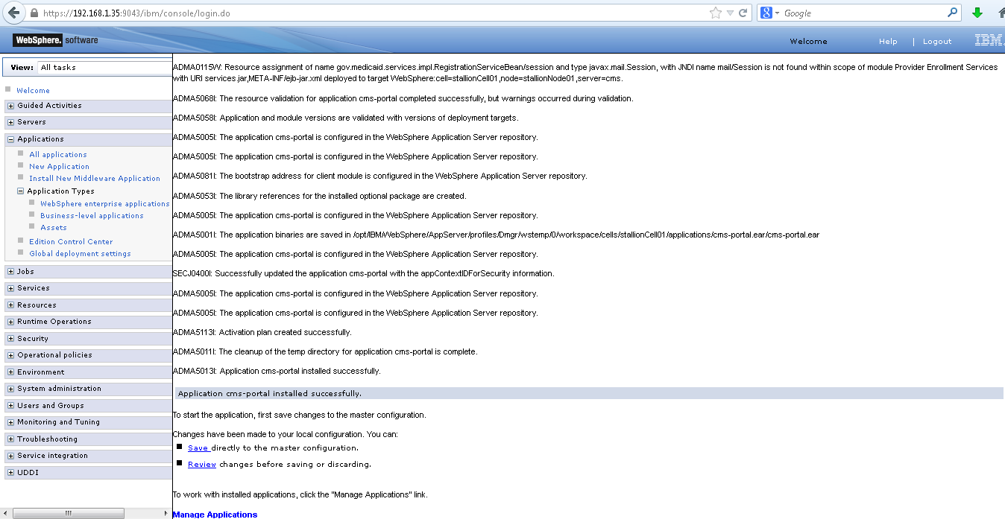

Select the application and click “Start”, the status should turn green

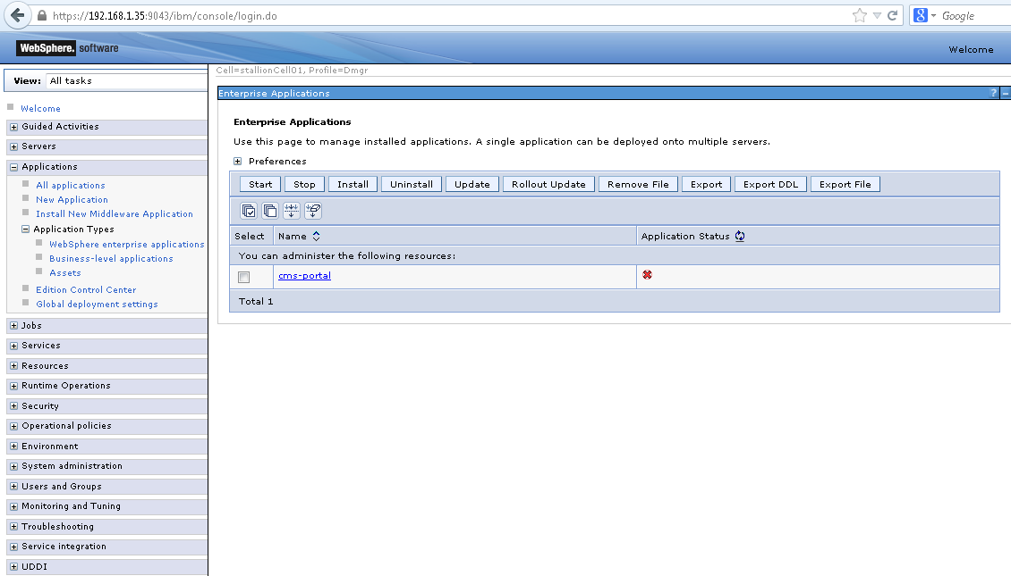

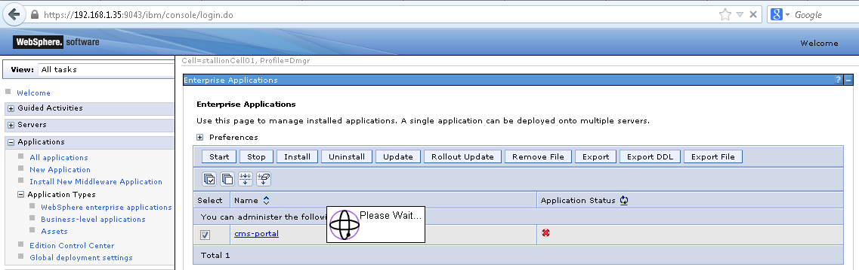

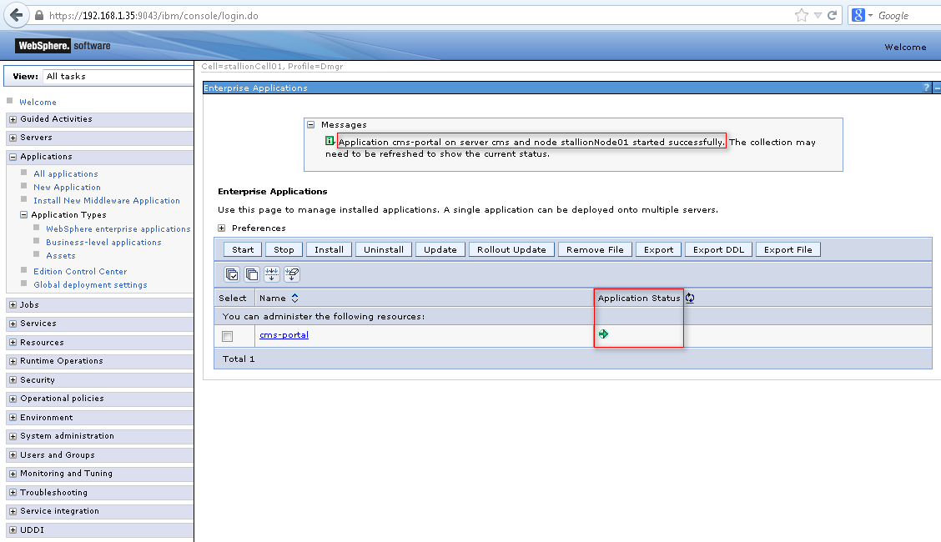

## Websphere environment Setup

*Note: You may run into out of memory errors using the default heap size, please adjust it to at least 1GB (less may work, but this was tested using 1GB), you may check the websphere documentation or follow the below guide to setting the heap size, please restart websphere after setting a new value.*

[*http://www.mkyong.com/websphere/how-to-increase-websphere-jvm-memory/*](http://www.mkyong.com/websphere/how-to-increase-websphere-jvm-memory/)

## Data Source Setup

You need to setup 2 data sources and a mail provider. The next steps assume that you are logged in to WAS8.5 console

[**Resources**](javascript:expandCollapse('12');) **🡺 JDBC 🡺 Data sources**

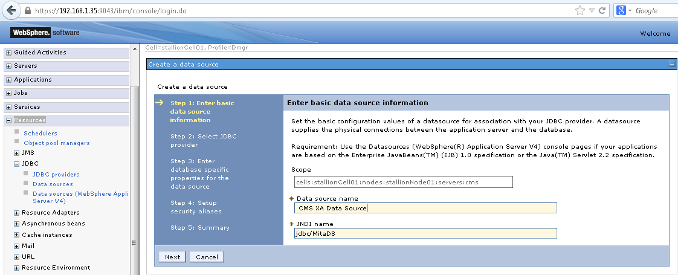

* To setup authentication (db user), from the left navigation go to Security > Global Security >
* Click on “Java Authentication and Authorization Service” it should show several options, click on “J2C authentication data”
* Click “New” and Enter the database user information

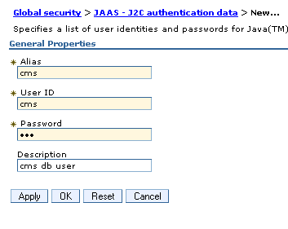

* Apply and Save the configuration changes
* Navigate to Resources > JDBC > JDBC Providers, Select you node and click on “New”
* Enter the database type (oracle), provider type (Oracle JDBC Driver), Implementation Type (XA data source). Click Next.
* (Optional) Enter the oracle driver jar and click on “Apply”
* Enter the location of the jar specified then click “Next”
* Review the settings and click “Finish”

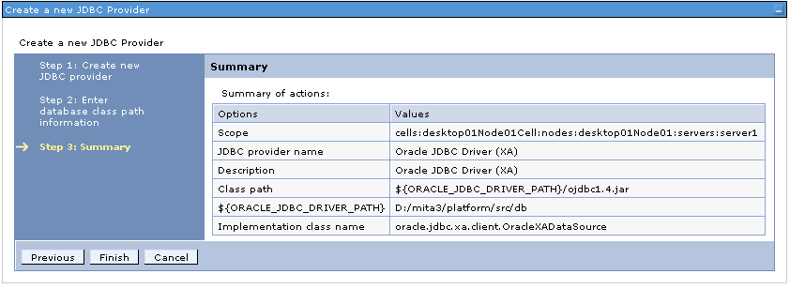

* Create another provider, this time, select the implementation type as Connection Pool Data Source
* Navigate to Resources > JDBC > Data sources, Click on “New”
* Enter the data source name (CMS XA Data Source) and the JNDI name (jdbc/MitaDS)
* Click Next, Select the XA datasource provider created earlier
* Click Next, Enter the database URL. Leave the rest as default.
* Click Next, Select the J2C authentication data created earlier for “Authentication alias for XA recovery”, “Component-managed authentication alias” and “Container-managed authentication alias”. Leave the rest as default.
* Click On Next, Finish then Save. Test your data source.
* Create another DS. Click On “New”
* 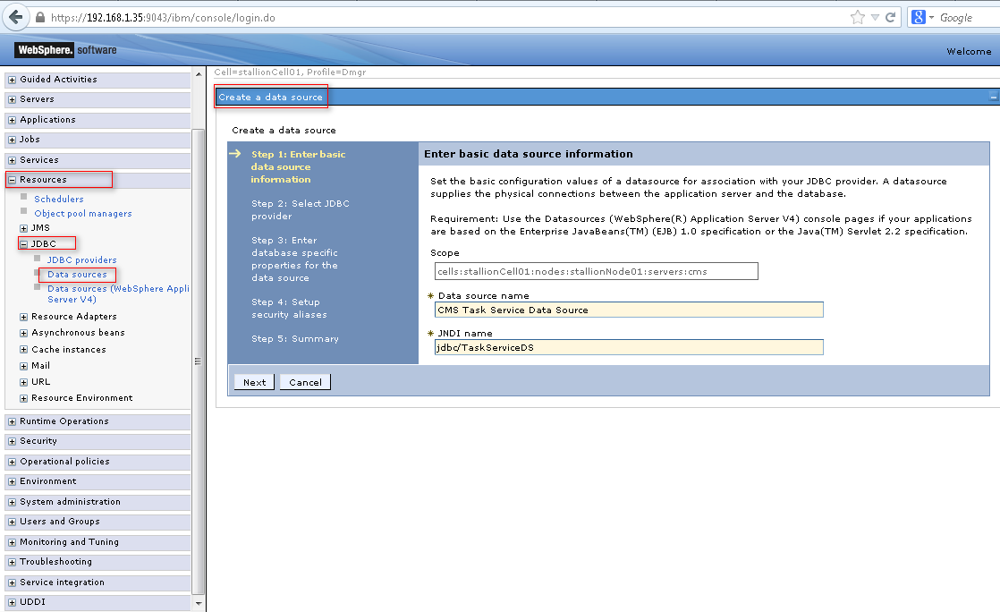
* Enter the name (CMS Task Service Data Source) and JNDI name (jdbc/TaskServiceDS)
* Click Next. Select the connection pool datasource provider created earlier.
* Click Next. Enter the database URL, uncheck the box “Use this data source in container managed persistence (CMP)”
* Click Next. Select the J2C authentication data created earlier for “Component-managed authentication alias” and “Container-managed authentication alias”
* Click On Next, Finish then Save. Test your data source.

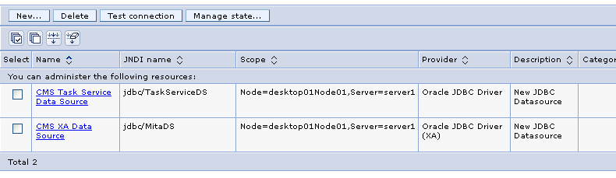

* Navigate to Resources > Mail > Mail sessions. Click “New”
* Enter the name (CMS Mail Session) and the JNDI Name (mail/Session).
* Enter your mail server settings (only outgoing is necessary)
* Leave the rest as defaults
* Click on “Apply”, then Save.

Select Task Service data source and test connection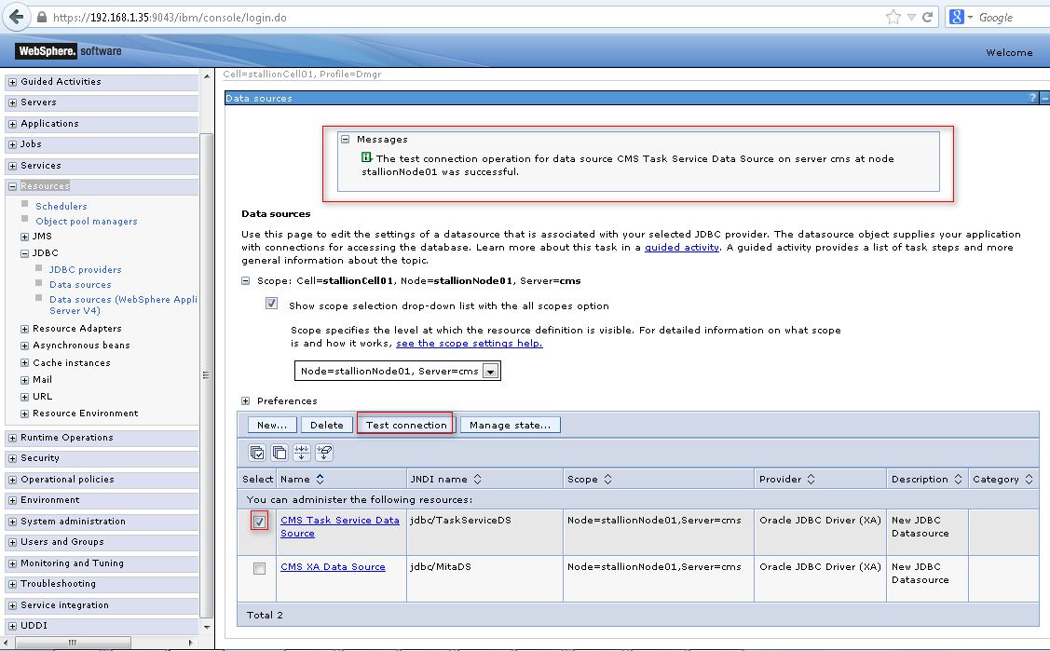

Select CMS data source and test connection

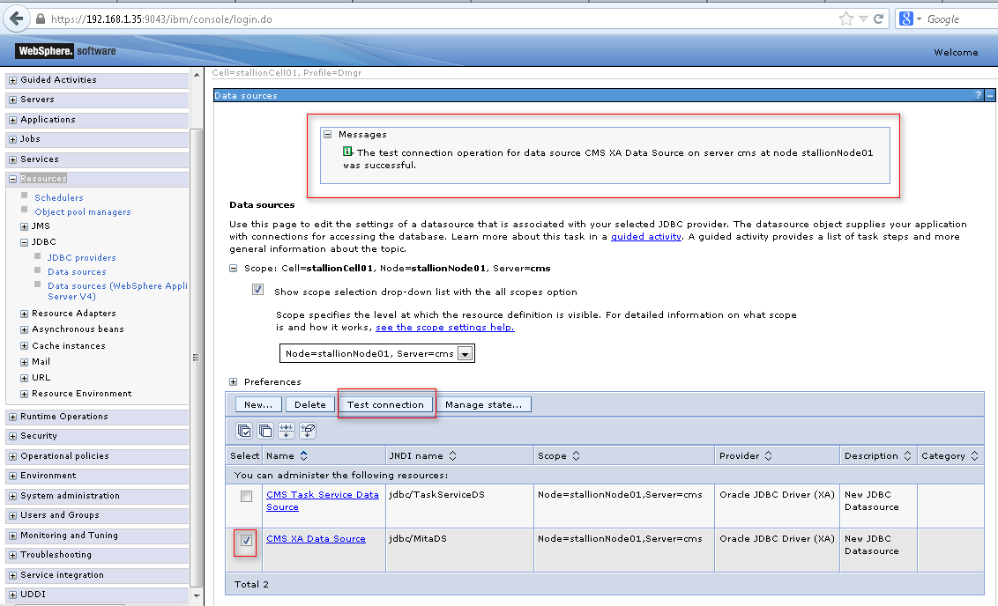

## Install Guvnor

* EXTRACT Guvnor-distribution-5.3.0.Final from Jboss web site

1. Download IBM WAS liberty profile.

wget <https://public.dhe.ibm.com/ibmdl/export/pub/software/websphere/wasdev/downloads/wlp/8.5/wlp-developers-8.5.0.2.jar>

2. Install it to a preferred directory say {install.dir}.

java -jar wlp-developers-8.5.0.2.jar

3. Navigate to  {install.dir}/wlp/bin/ and create the server

Make sure guvnor is set to port 9081.

./server create guvnor

4. Download and deploy guvnor 5.3.0 (this is the version working in websphere without any issues).

curl -O -L <http://download.jboss.org/drools/release/5.3.0.Final/guvnor-distribution-5.3.0.Final.zip>

unzip guvnor-distribution-5.3.0.Final.zip

unzip guvnor-distribution-5.3.0.Final/binaries/guvnor-5.3.0.Final-tomcat-6.0.war -d guvnor

cp -r guvnor {install.dir}/wlp/usr/servers/guvnor/apps/

5. Update server.xml using right port to access Guvnor

vi {install.dir}/wlp/usr/servers/guvnor/server.xml

6. Start the server.

Go to directories cd {install.dir}/wlp/bin

./server start guvnor

Log files will be present in {install.dir}/usr/servers/guvnor/logs/

Open the guvnor console using <http://10.169.169.18:9081/guvnor/org.drools.guvnor.Guvnor/Guvnor.jsp>

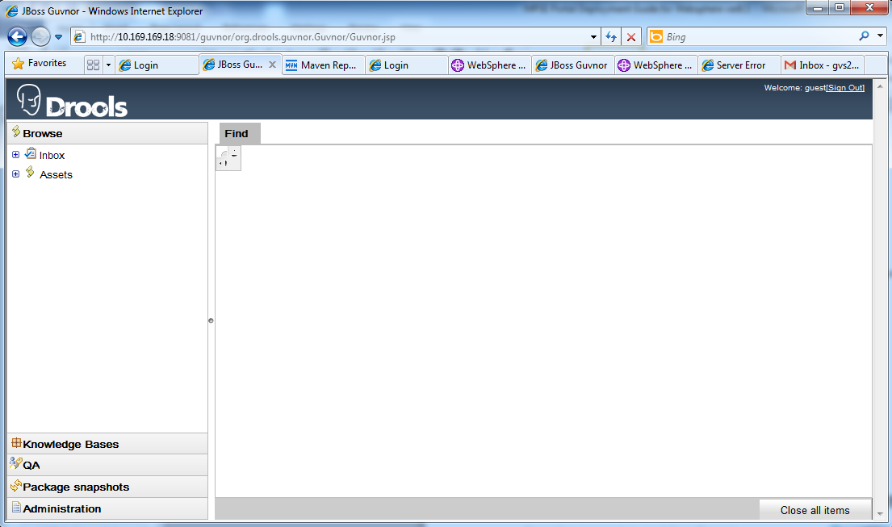

* + Click tab “Knowledge Bases” from left side
  + Click “Create New”
  + Select “New Package”
  + Import all the DRL files from /cms-business-process/src/main/resources

<https://github.com/nasa/coeci-cms-mpsp/tree/master/pesp-was8.5/cms-business-process/src/main/resources>

Please find the .DRL files attached screen shot below and import them in Guvnor.

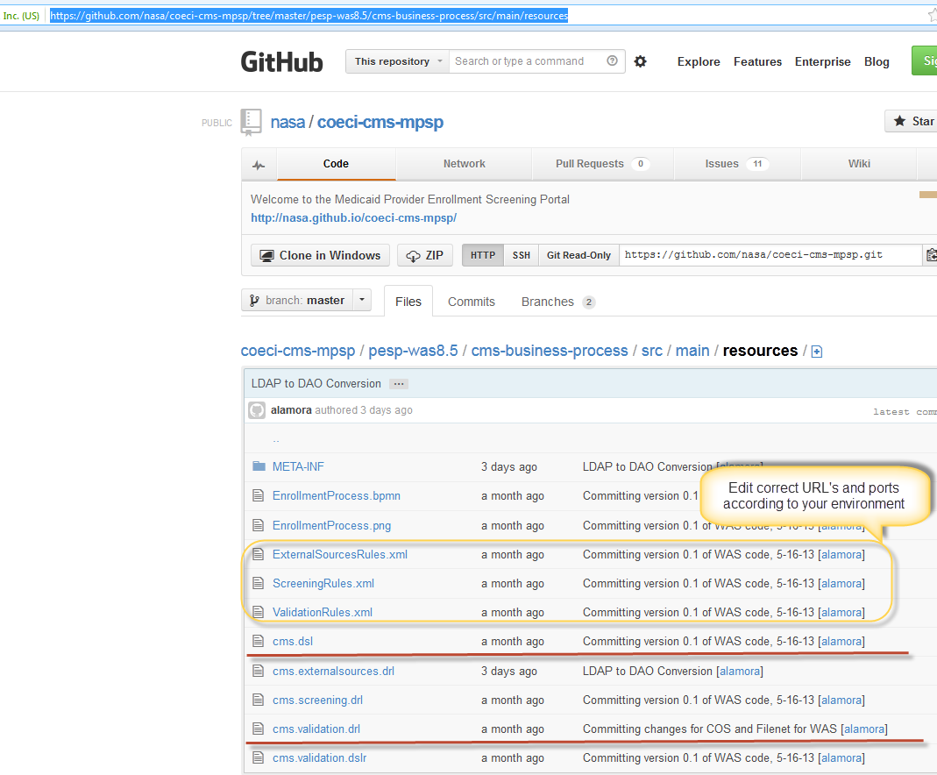

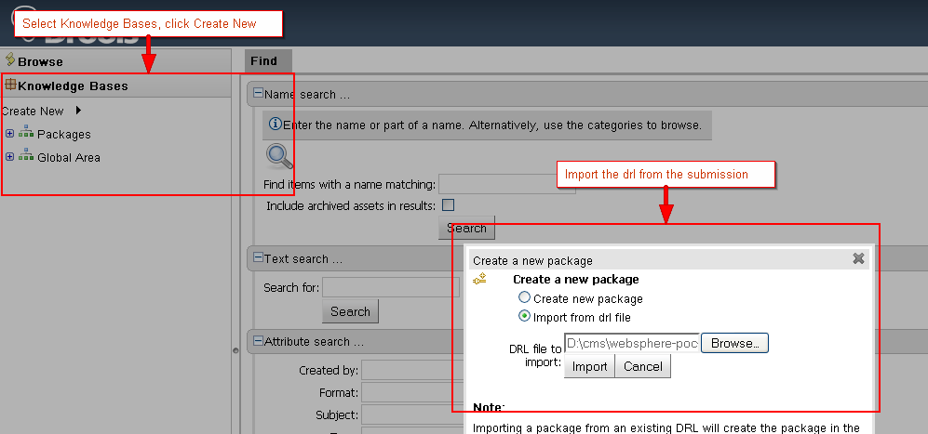

Guvnor is up and running on VM2. You can view MPSE business rules by using the below link / URL

<http://10.169.169.18:9081/guvnor/org.drools.guvnor.Guvnor/Guvnor.jsp>

First click the Knowledge Bases link on your left side and click on packages , then you can see three packages. You can click one of them and explore them each one.

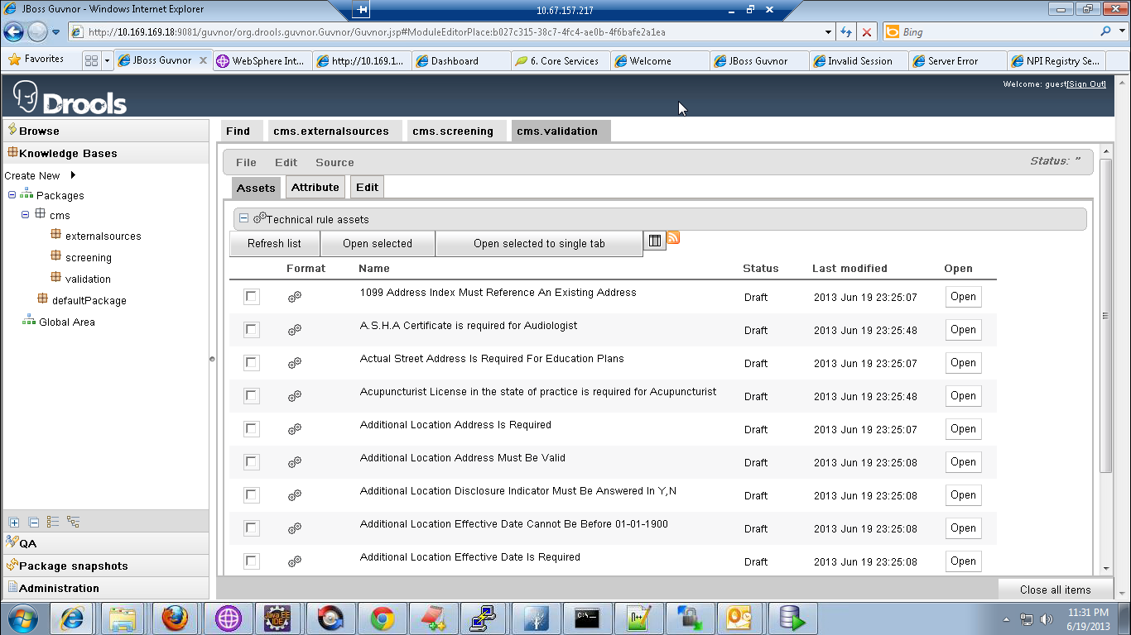

## Build Scripts Setup

* + 1. **application/build.xml**

The following targets are available:

build-core Builds the core archive

build-ejb Build the EJB archive

build-war Builds the web archive

clean Removes all generated files

dist Generates the portal ear artifact

regenerate-model Regenerates the application model from the schemas

(some old targets for jboss are kept)

* + 1. **application/build.properties**

// this is the only property relevant to websphere deployment

was.home – location of websphere 8.5

## Configuration Files

* + 1. services/src/main/resources/cms.properties

Contains the application settings, unless you will use different JNDI names, you can leave this as is for this assembly.

# Summary of Deployment steps

* Setup oracle and websphere per instructions above
* execute “ant dist”, this will create the archive under the folder “build”
* Log in to the WAS console
* Navigate to Applications > Application Types > Websphere enterprise applications
* Click “Install” and upload the generated ear file from by ant script
* Click Next. Accept All Defaults for all the screens
* Click On Finish, wait for installation to complete, then click Save.
* Select the application and click “Start”, the status should turn green

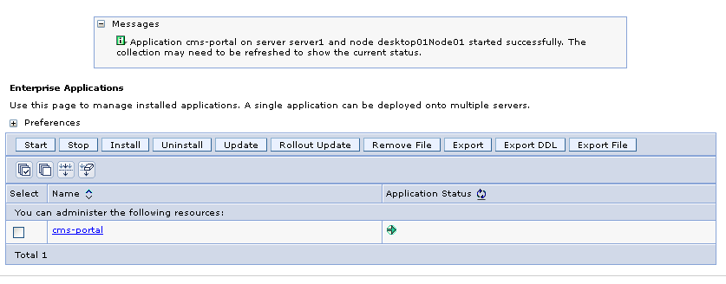

# Start Websphere Server

The app is started through the websphere console (see Deployment Instructions).

# Portal Application Verification

* Open <http://localhost:9080/cms/login>
* Login via admin/admin
* Perform regression testing such as save/submit/approve

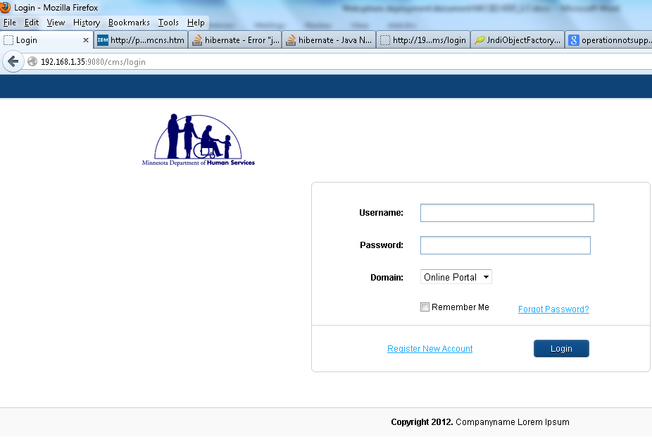

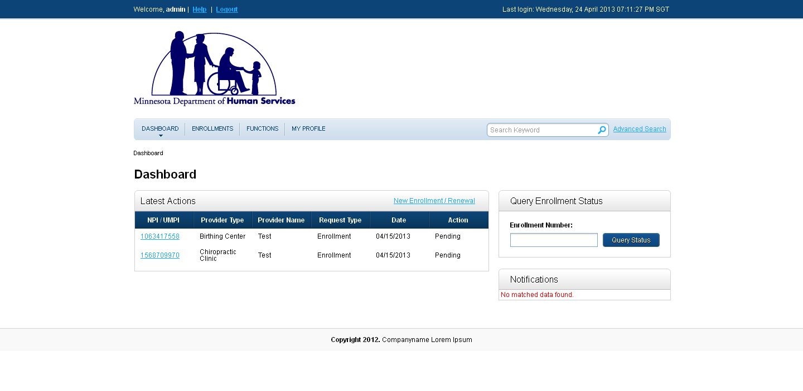

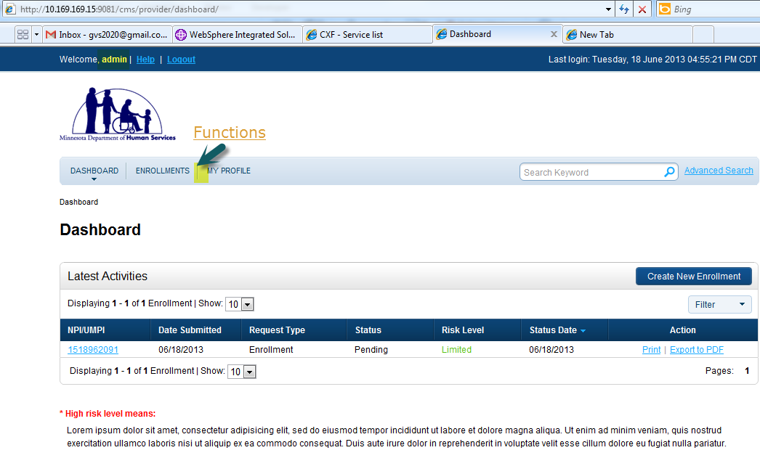

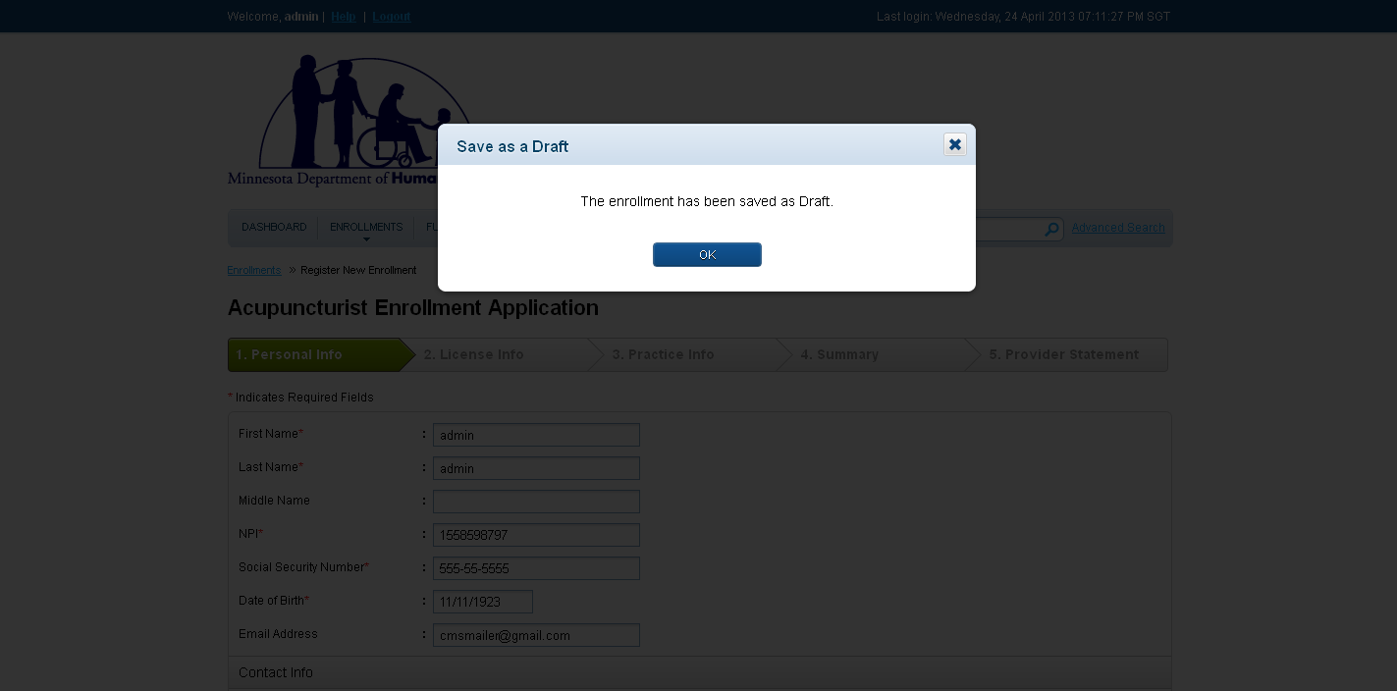

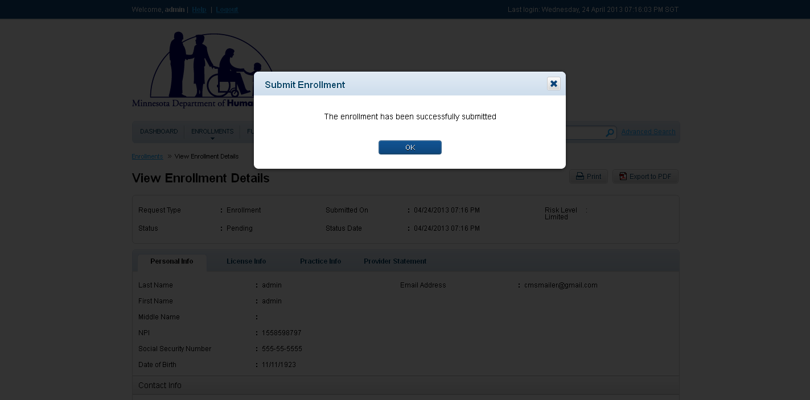

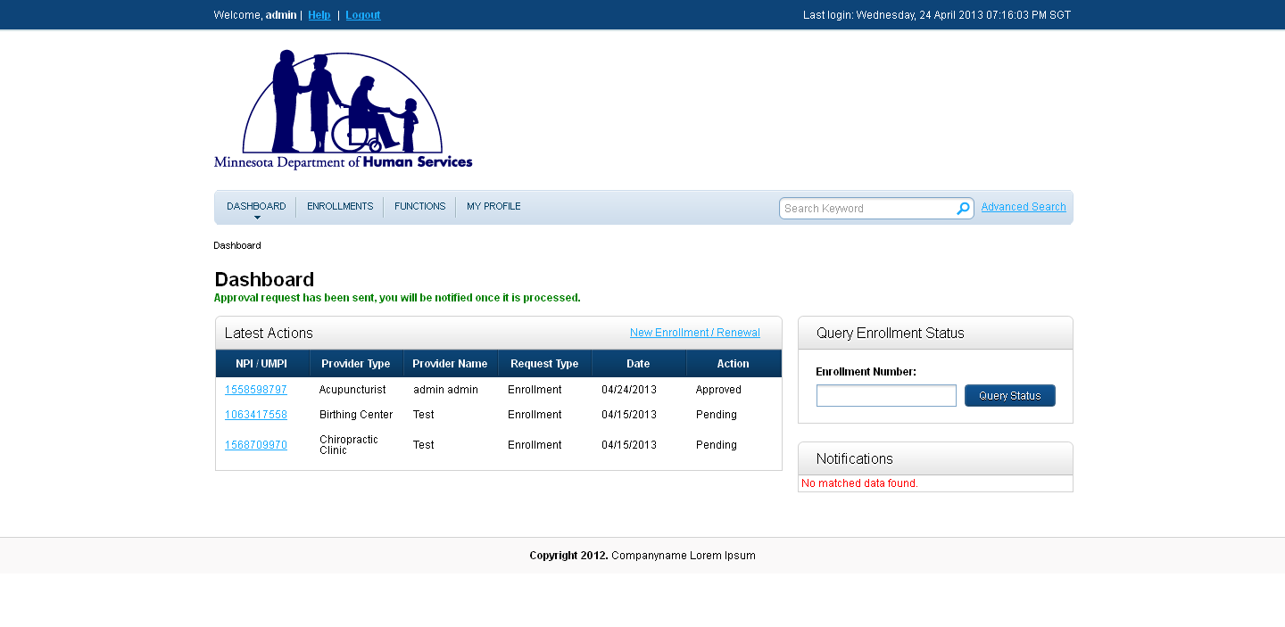

# Resource Contact List

|  |  |  |
| --- | --- | --- |
| **Name** | **Description** | **Contact** |
| Frank Griffin | Project Manager | [frank.griffin@newwave-technologies.com](mailto:frank.griffin@newwave-technologies.com)  410-782-0476 X2002 |
| Venkat Guruvelli | Portal System Integrator | venkat.guruvelli@newwave-technologies.com  410-782-0476 X2018 |
| Rony John | Java Developer | rony.john@newwave-technologies.com  410-782-0476 X2021 |
| Andy LaMora | Program Manager | [alamora@topcoder.com](mailto:alamora@topcoder.com)  917-312-7406 |

# Minnesota Specific Configuration Changes